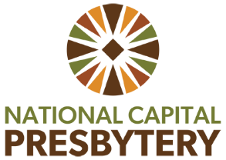

Teaching Elder Care and Nurture (TEC-N)
Coaching and/or Spiritual Direction Grant

The Teaching Elder Care and Nurture Team (TEC-N) has funding available for grants for Teaching Elders to receive coaching and/or spiritual direction. Please read the information below and complete the application questions below to request a grant for coaching and/or spiritual direction.

Grant criteria:
- Ordinarily grants to Teaching Elders are not to exceed $400 per calendar year
- These grants are issued on a rolling basis, as funding allows.
- Teaching Elders who are requesting a grant from the TEC-N Team for the first time are prioritized.
- Please allow up to 3 weeks after application to receive an email reply from the TEC-N Team as to whether funds are granted.
- The TEC-N Team will work with grant recipients, their spiritual directors/coaches and National Capital Presbytery Staff to ensure payment is made in a timely manner
Answer the following questions:
1. Teaching Elder name and email address
2. Tell us a little bit about what you are requesting the funds for (coaching/spiritual direction) and if you have a coach or spiritual director in mind or if you need help finding one.
3. Do you receive any funds such as professional expense funds from your church/ New Worshipping Community/etc. that would also financially contribute to this coaching/spiritual direction?
4. Is there anything else that the TEC-N Team should know as we consider your grant request?
5. Have you received a grant from the TEC-N team within the past calendar year?

Email your application to the TEC-N co-chairs Rev. Emma Horn ehorn@ipcmclean.org
and Rev. Larry Golemon lgolemon@washtheocon.org

