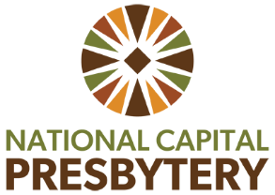

Teaching Elder Care and Nurture (TEC-N)
Clergy Group Grant

The Teaching Elder Care and Nurture Team has funding available for grants to Clergy Groups to support the spiritual nurture, fellowship, and education of NCP's clergy groups. Please read over the information below and complete the application questions below to request a grant for your clergy group.

Grant criteria:
- Ordinarily, grants to clergy groups are not to exceed $400 per calendar year.
- These grants are issued on a rolling basis, as funding allows.
- Clergy groups who are requesting a grant from the TEC-N for the first time are prioritized.
- Please allow up to 3 weeks after application to receive an email reply from the TEC-N Team as to whether the funds are granted.
- Generally, grant monies are given on a reimbursement basis from National Capital Presbytery
Answer the following questions:
1. Contact Person Name and Email Address for the Clergy Group
2. Tell us a little bit about your clergy group (Specific names of group members aren't needed), i.e. Is this a group of associate pastors, solo pastors, pastors connected by geography, etc.
3. What does your clergy group plan to use these funds for? What is the rough cost of these plans? Ideas for how to use this funding includes but are not limited to: reading and discussing a book together, bringing in a special speaker for the group, planning a day away at a camp or retreat center or other location, a shared meal or experience somewhere, etc.
4. Is there anything else the TEC-N Team should keep in mind as we consider your grant request?
5. Has your clergy group received a grant from the TEC-N Team within the past calendar year?

Email the application to the TEC-N co-chairs Rev. Emma Horn ehorn@ipcmclean.org
and Rev. Larry Golemon lgolemon@washtheocon.org

